DAC_Phase 3: Development part 1

IBM Cognos for visualization

**Churn by Gender:**

* Churn No has the highest total TotalCharges due to gender Female
* Gender Male has the highest TotalCharges at over 8.1 million, out of which Churn No contributed the most at nearly 6.6 million.

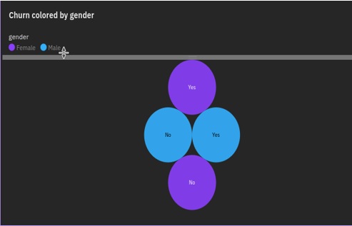

**Churn By SeniorCitizen:**

* Churn No has the highest values of both SeniorCitizen and TotalCharges.
* Across all values of Churn, the sum of SeniorCitizen is over a thousand.
* SeniorCitizen ranges from 476, when Churn is Yes, to 666, when Churn is No.

**Churn By Tenure:**

* No exceeds Yes in tenure by 160,784.
* Churn **No** has the highest values of both tenure and TotalCharges.
* Over all values of Churn, the sum of tenure is almost 228 thousand.
* Tenure ranges from almost 34 thousand, when Churn is Yes, to over 194 thousand, when Churn is No.

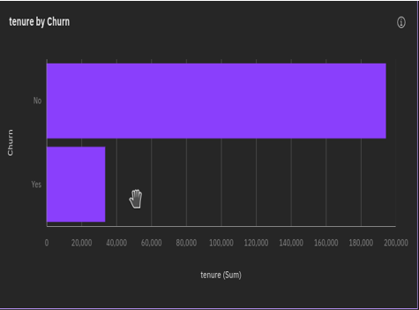

**Jupyter Lab Program:**

